**NAMUR FLX-Series Solenoid Valve**

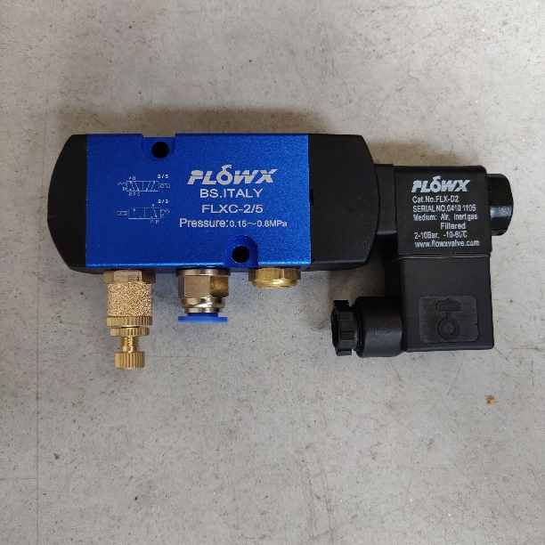



Brand: FLOWX  
Type: FLXC-2/3, FLXC-2/5  
Pressure: 6kg  
Temperature: -10°C ~ +80°C