CryoDAM-Y-Flow
Valves for Liquid nitrogen, Argon, …
On/Off and proportional controller
Series | CryoDAM-Y-Flow (size)
Function | normally closed
Operation | Pneumatic
Body | SS304
Temperature  Connections  Pressure min/max  Seal | -196 + 200°C  Screw or weld DN15-20-25-32-40  0 – 16Bar 0-230Psi  PTFE
Actuator | SS304-Polyamide-Aliminium
Ambient Temperature | -20 + 50°C
Pneumatic supply | 7 Bar / ¼”
Control type | Single / double acting
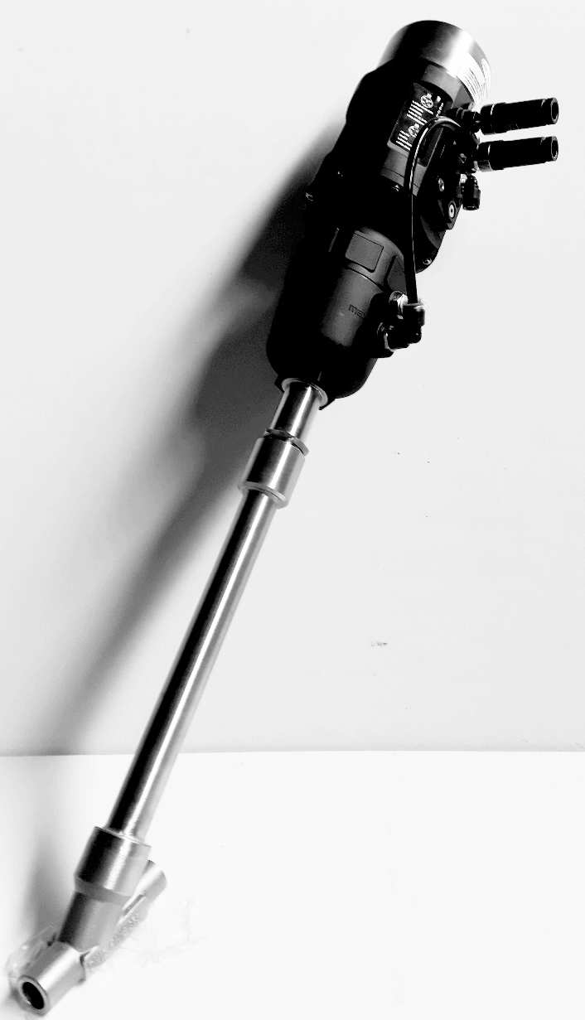

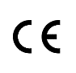
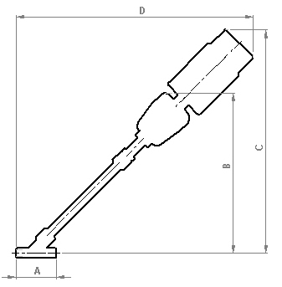

Sizes | ½” | ¾” | 1” | 1 ¼” | 1 ½”
A | 85 | 95 | 105 | 120 | 130
B | 370 | 378 | 398 | 383 | 393
C | 500 | 510 | 528 | 518 | 528
D | 525 | 531 | 563 | 553 | 561
Orifice/mm | 13 | 18 | 24 | 31 | 35
Kv m³/h | 4.6 | 8.8 | 15.7 | 23.4 | 31.3
Dimensions in mm

Safety instructions
*This product is not a safety device and may not be used as such.
*Damage caused by improper operating conditions or other reasons, may cause improper functioning of the valve.
*Correct transport, proper storage and installation, and proper use and maintenance, are essential for reliable and error-free operation.
*Installation and repair work may be carried out by authorized technical people only.
*It is the responsibility of the user to select the right product for the application.
*The product may not function properly as a result of dirt, wear, damage (for example, by dropping) or improper use. Therefore, the product should not be used in applications where a malfunction can cause danger or damage.
*This product is not intended or approved for medical applications.
*Y-Flow valves can only be used with clean liquids or gases.
*Beware of cold surfaces when used for cryogenics.
*It is recommended to install a filter before the valve.
*Check the compatibility of the medium used, temperature and other operating conditions with the materials and specifications of the product.
*Never exceed the limits for pressure as indicated on the product and/or in the technical documentation.
*The air supply must be dry, clean and in range.
*Warning: a valve opens and closes quickly. Improper use can cause pressure transients (fluid hammer) in the pipes with possible damage as a consequence.
*It is not allowed to change the construction valve.

Installation and Maintenance
Safety before starting
* It is recommended to install the product in a dry environment. In moist environments, make sure that no moisture can penetrate the ports, actuator or connectors. Install the valve in a safe way to avoid cold burning or other injuries in case of use with cryogenics. Ensure that the valve is installed in an area with adequate ventilation. Make sure the valve is not in contact with or in the vicinity of flammable materials. Ensure that the product is protected and clean.
* Use the appropriate sealant according to the media for screw connections.
* Weld connections can only be performed by authorized and certified people
* Operations may only be performed when the system is not pressurized, electrically disconnected and in ambient temperatures.
* Turn off the power and pressure supply before performing any work on the valve to prevent the risk of accidents and to prevent activation of the valve.
* The product is only safe when properly installed and operated by qualified persons. Please read the safety instructions and technical documentation carefully before installation, use or maintenance.
* Always make sure to start the installation safely after installation or maintenance check.
* Water hammer is a typical consequence of a high flow rate and pressure in pipes with small diameters. Possible water hammer by incoming flow above seat.
There are several solutions to this problem:

Installation
* The valve can be used in combination with cryogenic liquids or gases. Make sure that the pipe may not contain dirt before installing the valve. It is recommended to install a filter (500 μm) before the valve.

* Be aware of the direction of flow of the medium when installing the valve. valves with an arrow on the housing must be connected in the indicated direction. The pipes on both sides of the valve must be securely fastened or welded by certified technicians. Use a wrench for both valve and pipe while tightening to prevent unnecessary stresses in the system. The valve can be extra fixed by clamps under the actuator. Use only clamps who proper fits the stainless steel diameter (do not cover the release bore). Only exert force at the designated areas on the body such as the hexagon; never to the actuator or control head. Avoid vibration in the pipes. Use a suitable sealant for threaded connections of the valve. Avoid the entry of thread sealing material in the valve, this can lead to malfunctioning of the valve.

* Important note in case of welding or maintenance check!

!!!Welding can only take place with open valve!!!

Ensure that the valve is in the open position before turning the actuator head and/or for disassembly.
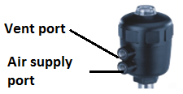
Procedure:
-Secure the body
-pressurize the air supply port (6Bar), keep vent port free
-Use a suitable wrench and open the stainless steel hexagon
Counter-clock wise

Assembly as well in pressurized condition!
Check the condition of the seal before assembly, replacement recommended.

* Install the valve in the positions as shown with the actuator facing upwards.
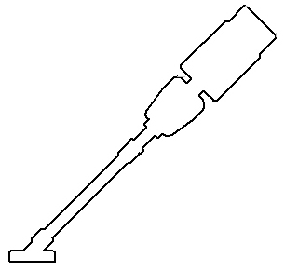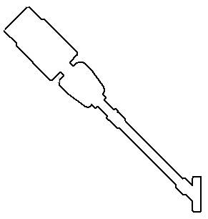

Only install in these positions!
Be aware of the flow direction!

* Make sure the valve is labelled with the valve characteristics. The device can be damaged by the use of unsuitable tools.

* The extreme low temperature of the body can causes cold burns when used with cryogenic fluids. Do not touch and protect the cold surfaces.

* Check the supply pressure before activating

* Check the air supply before activating the actuator head MAX 7 Bar.

* Only activate if you are sure no hazardous situations can occur.

Maintenance

A 6 month visual inspection should be taken by authorized people and the knowledge of cryogenic fluids. Intermediate checks are recommended.
The actuator is a maintenance free part, however pneumatic connections should be taken regularly.

Malfunctions
Actuator does not activate | Air supply not active: activate air supply (lowest port ¼”)
 | Air supply to low: pressurize (do not exceed limits)
 | Medium pressure to high: Lower the pressure
Valve seat leakage | Dirt : installation of filter recommended
 | Worn seat : installation of new seat
 | Medium pressure to high: Lower the pressure
Leakage trough release bore | Worn seals: Replace actuator

Disposal

The removal of the product should be performed in accordance with the applicable laws. Keep in mind the media that are still present in the valve.

Conformity

The CryoDAM-Y-Flow conforms with the EC Directives according to the EC Declaration of Conformity.

Certificate at the back of the document.

Manual for use with Positioner
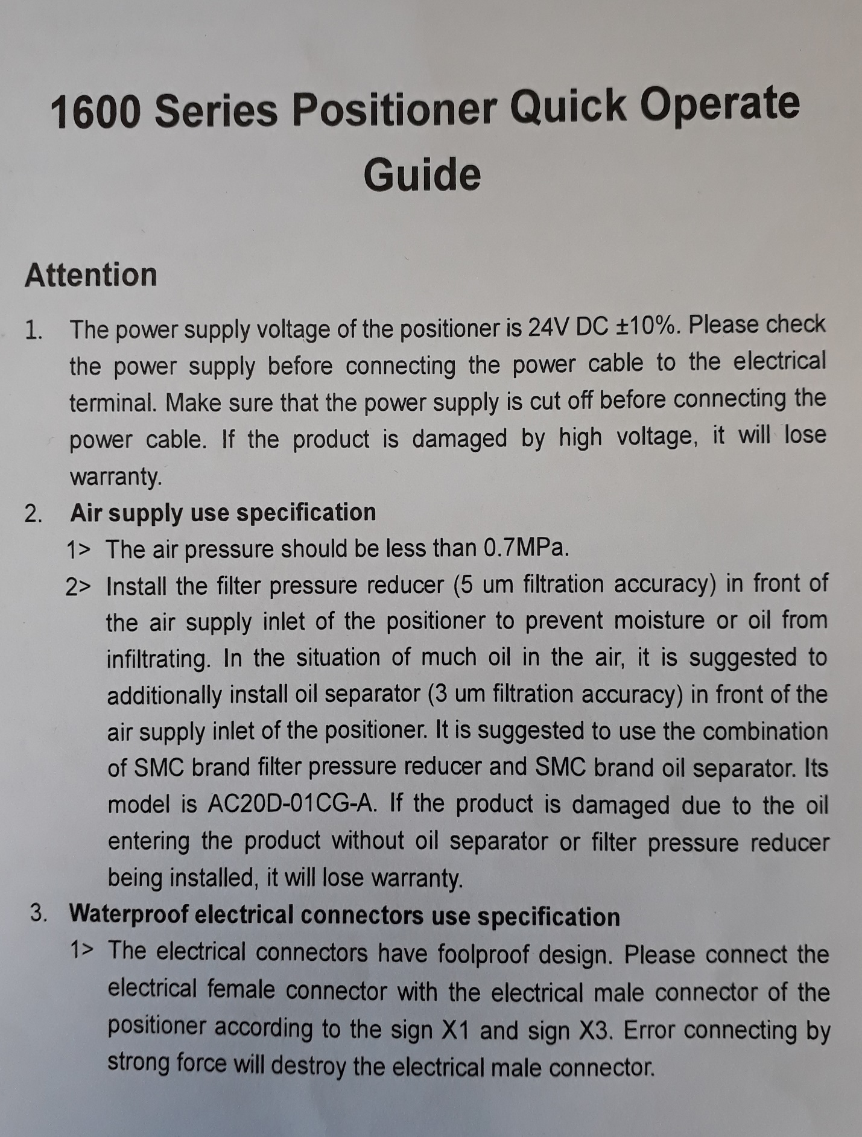

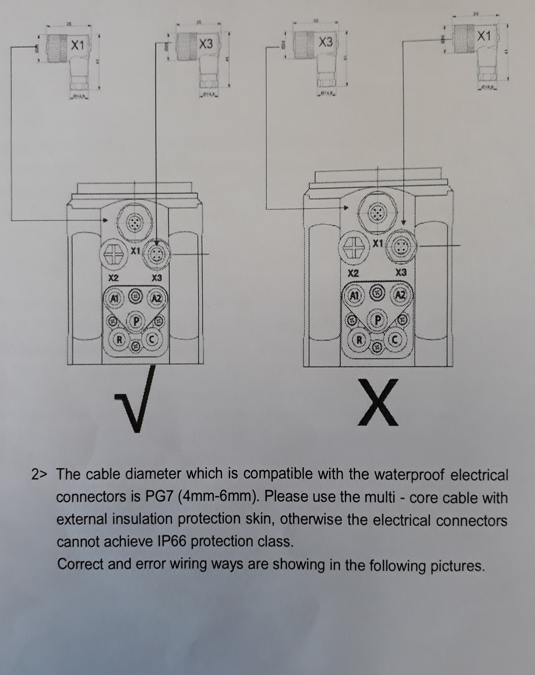

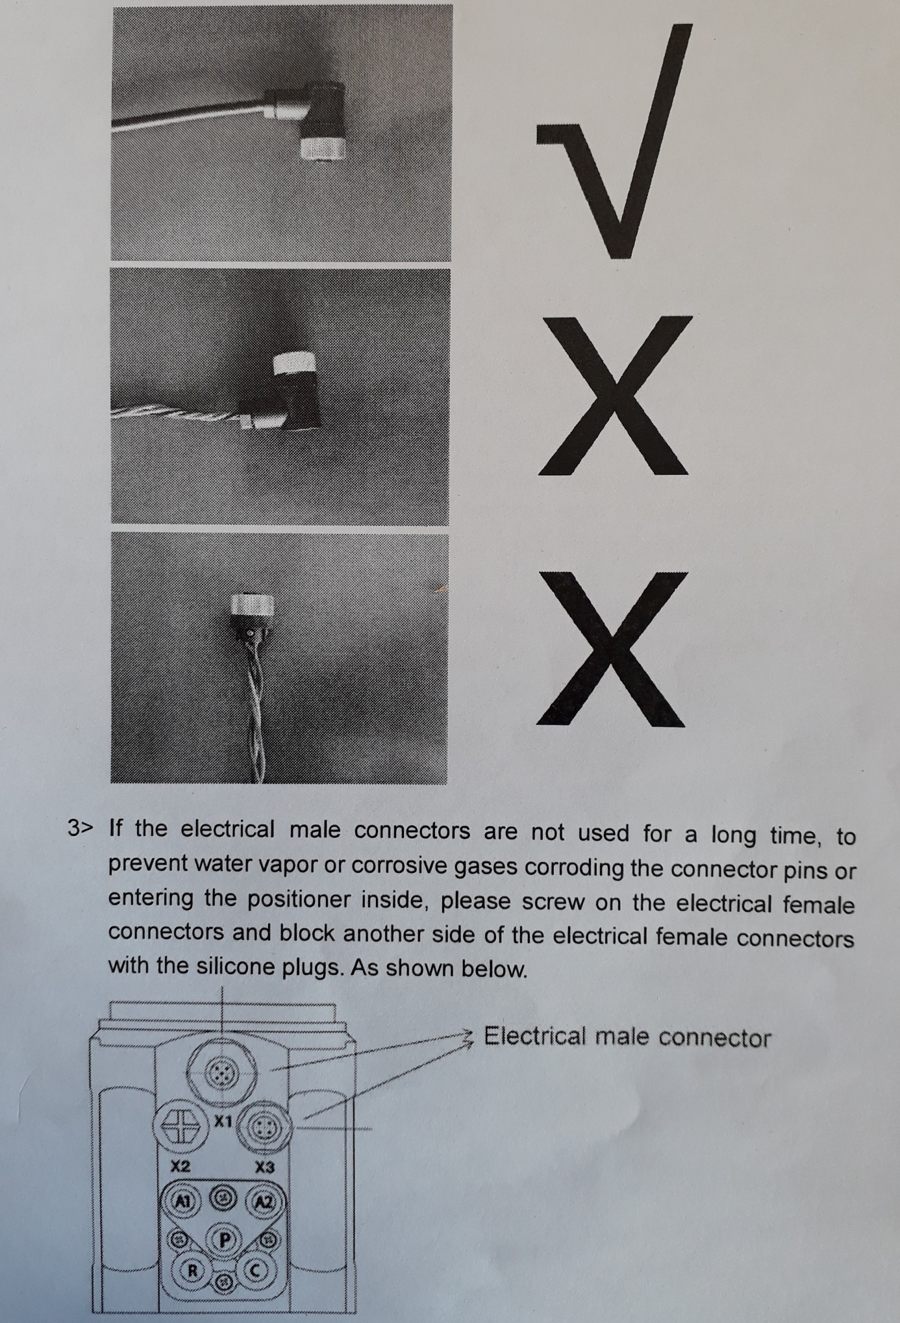

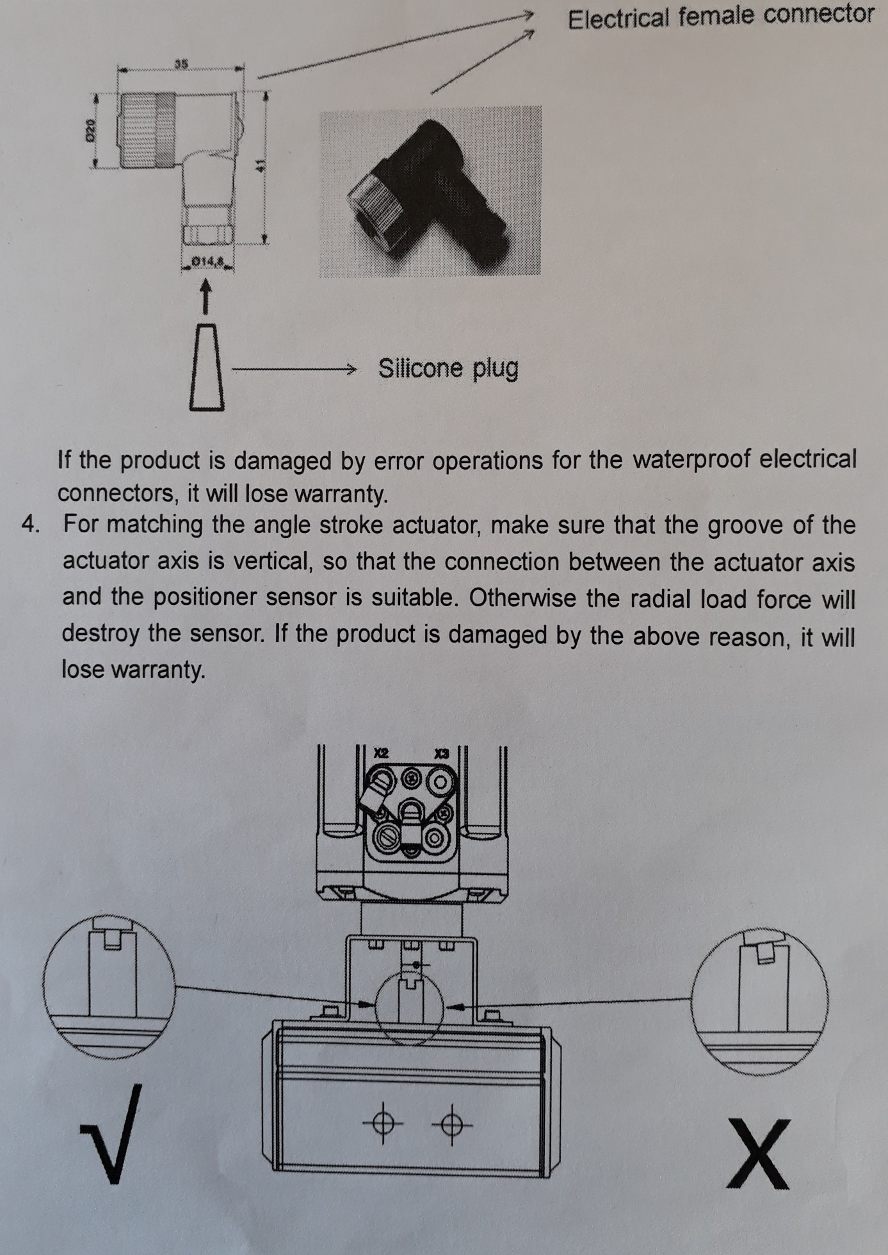

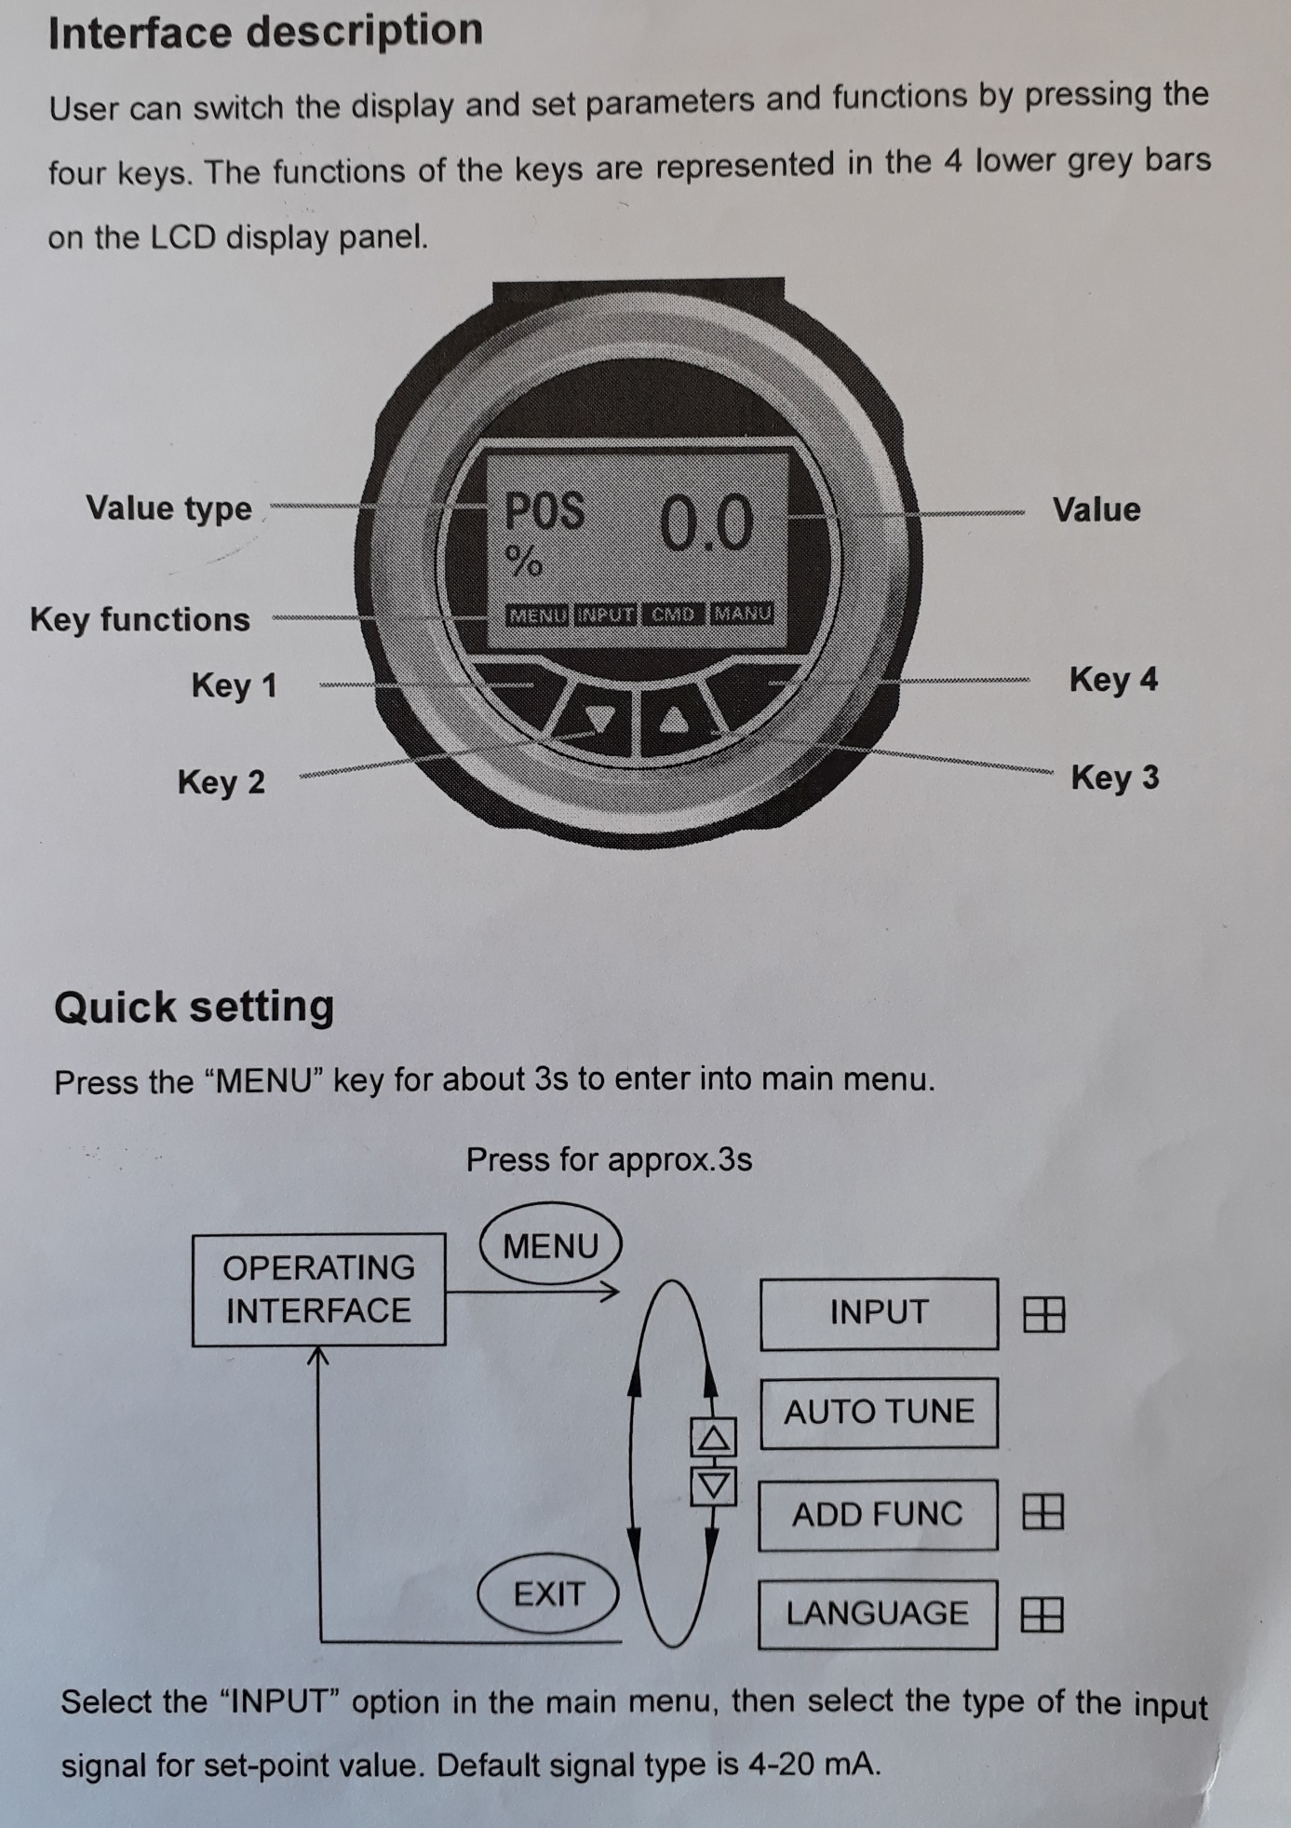

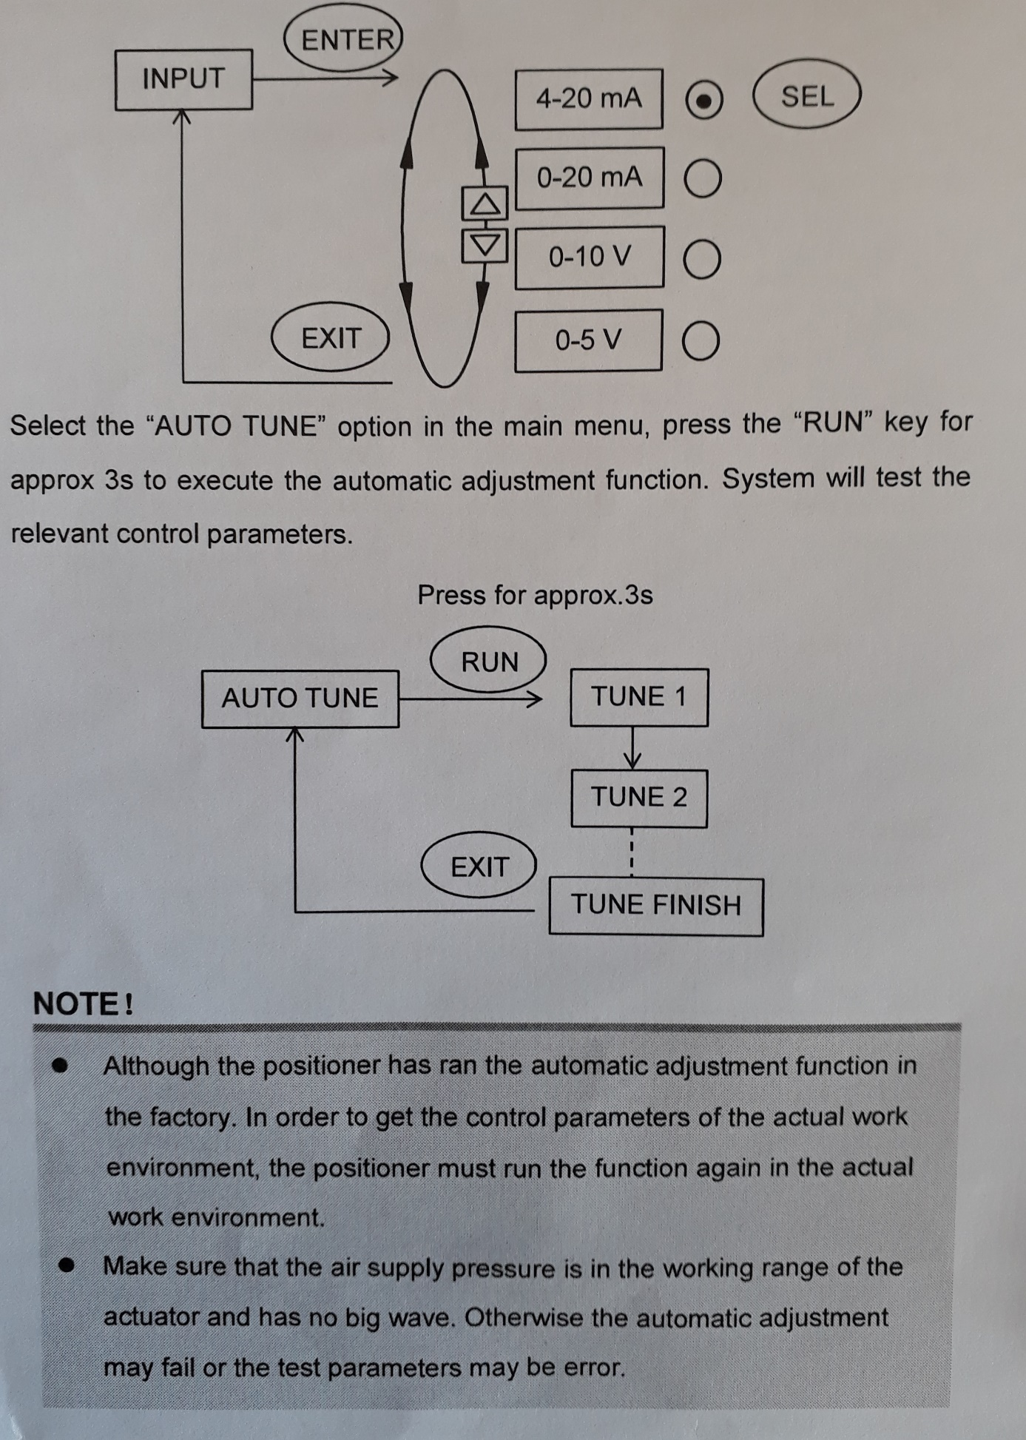

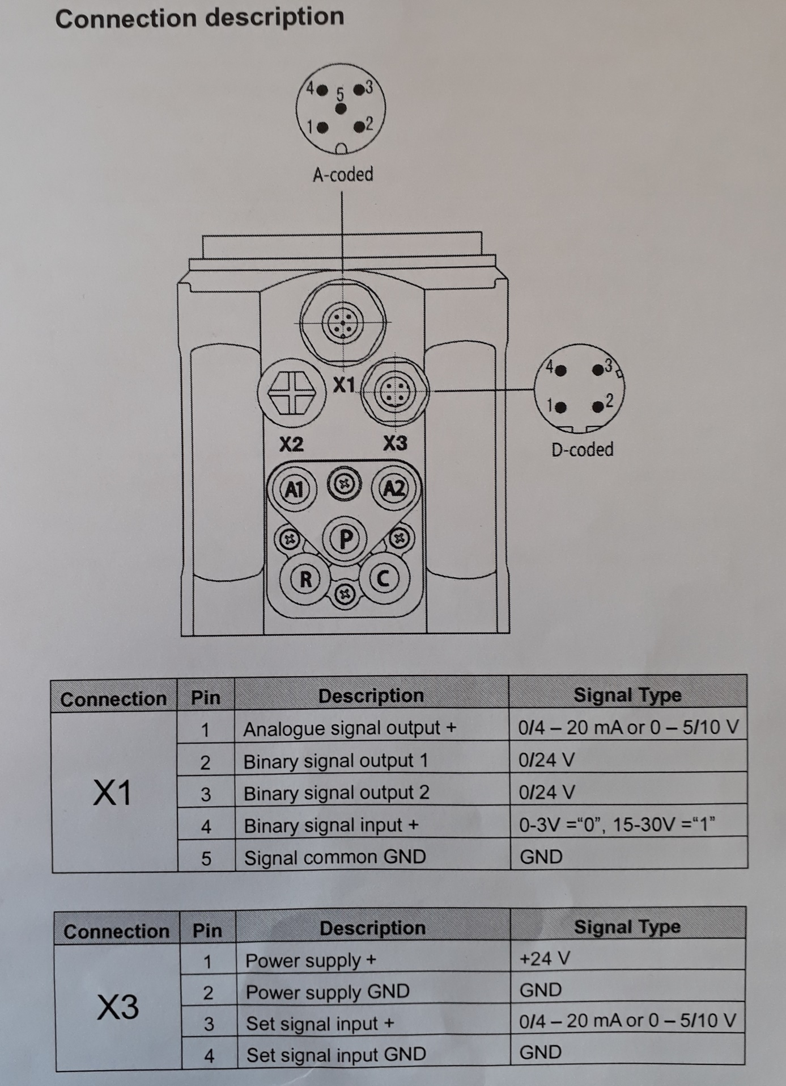

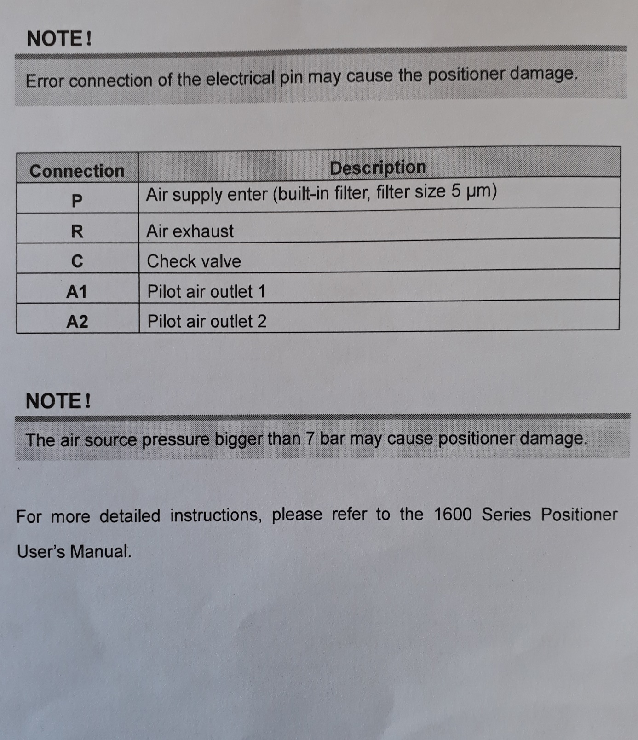

Contact:

Dam Tech bvba
Meensesteenweg 202a
8501 Bissegem
Belgium

Warranty

The warranty is only valid if the device is used as intended in accordance with the specified application conditions.

Document: DAM CryoDAM-Y-Flow version 20180106-1

Dam Tech bvba assumes no responsibility for any errors that may appear in this document

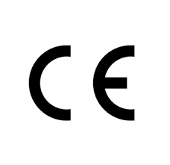
EU CONFORMITEITSVERKLARING
DECLARATION EU DE CONFORMITE
EU KONFORMITATS-ERKLARUNG
EU DECLARATION OF CONFORMITY

Fabrikant – Constructeur – Hersteller - Manufacturer
Dam Tech bvba
Meensesteenweg 202a
8501 Bissegem
België

Wij verklaren hiermee in eigen verantwoordelijkheid dat het volgende product: 2/2 pneumatische afsluiter voor cryogene doeleinden DAM-CRYO-YFLOW in bouwvorm DN 15, 20 & 25 is gebouwd volgens de richtlijnen 2006/42/CE & 2014/68/EU
Nous déclarons sous notre responsabilité que le produit suivan : 2/2 Vanne à piston cryogenic DAM-CRYO-YFLOW avec construction DN 15, 20 & 25 est construit selon les directives 2006/42/CE & 2014/68/EU
Wir erklären hiermit in eigener Verantwortung das folgende Produkt: 2/2 pneumatisches kryogenes Ventil DAM-CRYO-YFLOW im Bau befindliche Form DN 15, 20 & 25 ist nach den Richtlinien gebaut 2006/42/CE & 2014/68/EU
We hereby declare in our own responsibility that the following product: 2/2 pneumatic cryogenic valve DAM-CRYO-YFLOW in construction DN 15, 20 & 25 is built according to the guidelines 2006/42/CE & 2014/68/EU

België, Bissegem 06-01-2018
Mussly David

Document: DAM Conform 20180106-1

